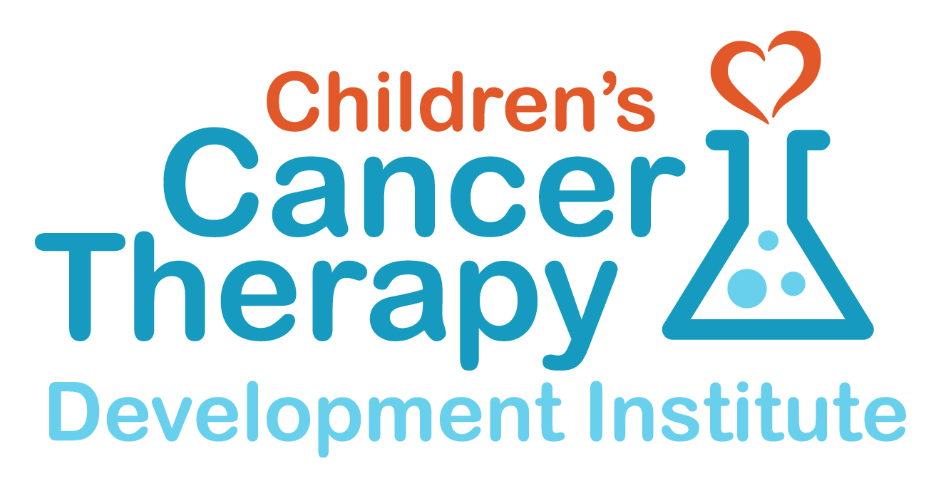
Pediatric Cancer Nanocourse
Curriculum
August 14 - 18, 2017
cc-TDI laboratory, 12655 SW Beaverdam RD W, Beaverton OR 97005

Registration (now closed):
https://cc-tdi.kindful.com/register/2017-pediatric-cancer-nanocourse

Goals:

The goal of the Pediatric Cancer Nanocourse is to train members of the public to act as informed liaisons between childhood cancer researchers and the community. Features of the course will include:

- a didactic overview of childhood cancer treatment, biology, pathology, and clinical trials
- an introduction to the scientific research process: how research works, what barriers exist, and how to overcome challenges and make progress on rare childhood cancers
- lectures on Bloom Syndrome and ETMR, as well as leptomeningeal metastasis of CNS PNET tumors
- daily mentorship and hands-on opportunities to shadow our research scientists in the laboratory
- a self-selected group research project, with the opportunity to collaborate with fellow participants
- the opportunity to build a network of informed and empowered advocates who can drive the cure of rare cancers
Previous course members have had their findings published in peer-reviewed scientific literature. There is no cost to attend the course, but participants are required to cover their own travel, lodging, and meals. Attendance is limited, so please register early to secure your participation.

2017 Participants:

Bloom Syndrome Team:
11 attendees

ETMR Team:
4 attendees

Metastatic leptomeningeal PNET:
6 attendees

undeclared:
6 attendees

Confirmed Lecturers:
Dr. Chris Cunniff (Weill Cornell), Bloom Syndrome and the BS Registry (Aug 13/14) cmc9039@med.cornell.edu
Dr. Mark Osborn (Univ of Minnesota), Gene Therapy for Fanconi Anemia/BS (Aug 14/15) osbor026@umn.edu
Dr. Nathan Ellis (Univ of Arizona), Questions in Bloom syndrome (Aug 15/16) naellis@email.arizona.edu
Dr. Sharon Plon (Baylor), inherited cancer predisposition wellness programs (Aug 14) splon@bcm.edu
Dr. Erin Rudzinski (Seattle Childrens), Bloom Syndrome cancer pathology (Aug 15) Erin.Rudzinski@seattlechildrens.org

Dr. Annie Huang (Sick Kids), ETMR Overview (Aug 15) annie.huang@sickkids.ca
Dr. Jonathan Hall (ETH Zurich), Lin28 inhibitors (Aug 15/16) jonathan.hall@pharma.ethz.ch
Dr. Mollie Meffert (JHMI), Lin28 Biology (Aug 14) mkm@jhmi.edu
Dr. Marcel Kool, (German Cancer Research Center), ETMR Functional Genomics (Aug 13-16) m.kool@Dkfz-Heidelberg.de
Dr. Mariella Filbin (DFCI), Single-cell genomics in pediatric brain tumors (Aug14-15) Mariella.Filbin@childrens.harvard.edu
Dr. Derek Hanson (Hackensack Univ Medical Center), ETMR trials (Aug 14-15) Derek.Hanson@hackensackmeridian.org
Dr. Bonnie Cole (Seattle Childrens), ETMR tumor pathology (Aug 15) Bonnie.Cole2@seattlechildrens.org

Molly Lindquist (Consano.org), crowdfunding for biomedical research (Aug 16) molly@consano.org
Ganapati Srinivasa (OmicsAutomation; Intel Collaborative Cancer Cloud, genomics (Aug 16) gans@omicsautomation.com
Tommy Pham (Nike), industry partnerships (Aug 17) tommy@cc-tdi.org

Pending Invitees:
Bloom Syndrome speaker on immunology/gene correction

Itinerary and Curriculum (2 tracks):

Mon Aug 14 | Bloom Syndrome | ETMR
8:30 am | Welcome & Introductions; Lab Tour | same
9:00 am | Overview from an Academic & Pharma perspective  - childhood cancer treatment  - clinical trials  - basic science research  - How to Cure Cancer from a Grassroots perspective: The Josh Sommer paradigm | same
9:45 am | Project Introduction & Team Designation (Project Lead/Writer, Sub-project Leads)  The goal of each project above is a roadmap manuscript in Frontiers | same
10:00 am | Bloom Syndrome Overview Chris Cunniff  Growth & Nutrition – when to intervene? Is growth hormone contraindicated?  Immune Dysfunction – what is it, what to do?  Diabetes – why, and are there prevention measures?  Cancer Surveillance – how? how often?  Cancer Prevention – is this feasible?  Relatives – what’s the cancer risk?  Cancer Treatment – surviving the first cancer while preventing a second?  Cures – exon skipping, gene editing and gene therapy?
10:55 am | same | ETMR overview deferred to Tue 10am
12:00 pm | Lunch (pizza or sandwiches) and Gene Therapy for Fanconi’s Anemia Mark Osborn | same
1:00 pm |  | Lin28 Biology Mollie Meffert
2:00 pm | Project Work Time * | same
3:00 pm | robotic drug screen: stage 1 of 2 with Noah Berlow | same
4:00 pm | Inherited cancer predisposition wellness programs Sharon Plon
6:00 pm | Group dinners with speakers (locations TBA) | same

* at various times, each person will rotate into the laboratory to shadow our scientists

Tue Aug 15 | Bloom Syndrome | ETMR
8:00 am |  | Leptomeningeal PNETs Morgann Turkot  This is not a formal roadmap project, unless a breakout team wishes to form.
9:00 am |  | ETMR Functional Genomics Marcel Kool
10:00 am |  | ETMR Overview Annie Huang  Lin28 drives the cancer. Therapeutics exist and continue to be developed. Few preclinical resources (cell lines or mouse models) have been developed. What is the path forward?
11:00 pm |  | Lin28 inhibitors Jonathan Hall
12:00 pm | Lunch on your own
1:00 pm |  | Single-cell Genomics in pediatric brain tumors Mariella Filbin
2:00 pm |  | ETMR Clinical Trials Derek Hanson
3:00 pm | Cancers at the first-hand cellular level: Erin Rudzinski speaking on Bloom Syndrome cancers; Bonnie Cole speaking on ETMR | same
4:00 pm | Project Work Time * | same
5:00 pm

Wed Aug 16 | Bloom Syndrome | ETMR
8:00 am | Project Work Time * | same
9:00 am | Immunology in Bloom Syndrome Khashayarsha Khazaie TBD
10:00 am |  | “The ETMR pilot project, hands on for you” Noah Berlow
11:00 pm | Grass Roots Patient-Centered Research Molly Lindquist | same
12:00 pm | Lunch on your own
1:00 pm | Genomic Decisions – All in a Day Ganapati Srinivasa | same
2:00 pm | Questions in Bloom syndrome Nathan Ellis | same
3:00 pm | Project Work Time *
5:00 pm

Thu Aug 17 | Bloom Syndrome | ETMR
8:00 am | Project Work Time * | same
9:00 am | Partnering with industry Tommy Pham | same
10:00 am | same | how I became a full time scientist for my daughter’s cancer Andy Woods
11:00 pm | same | Egg-static about preclinical research Samuel Rasmussen
12:00 pm | Lunch on your own
1:30 pm | same | robotic drug screen: stage 2 of 2 with Noah Berlow
2:00 pm | Project Work Time *
5:00 pm

Fri Aug 18 | Bloom Syndrome | ETMR
8:00 am | Project Work Time * | same
9:00 am | Project Finalization * | same
12:00 pm | Group Lunch (location TBA) | same
1:30 pm | Presentation of Completed Projects (manuscript submission?) | same
3:30 pm | Feedback Session
5:00 pm | Nanocourse Conclusion

Selected Pre-Reading & Media (not required):

I have mainly one video to suggest (Josh Sommer on his personal cancer journey and creating the Chordoma Foundation), an article, and a few short books. All of these are optional, but the video of Josh Sommer is the highest potential value. One of the books comes as a Hollywood movie.

The video of Josh Sommer: http://pcb-ohsu.blogspot.com/2011/04/college-student-dedicated-to-curing-his.html

The article: Understanding Academic Medical Centers: Simone’s Maxims. Joseph V. Simone. Clinical Cancer Research. Vol. 5, 2281–2285, September 1999 (available at http://clincancerres.aacrjournals.org/content/5/9/2281.long).

This article is written by one of the first oncologists to try giving more than one chemotherapy drug at the same time, in this instance for childhood leukemia. He is the ‘grandfather’ of pediatric oncology and very much active to this day.

A book that became a movie: The Cure: How a Father Raised $100 Million--and Bucked the Medical Establishment--in a Quest to Save His Children. ISBN-10: 006073440X

A painful but heartening book on just how far a parent can go to create a cure for their child. Its movie version, Extraordinary Mesures, with Brendan Frasier and Harrison Ford:
http://www.imdb.com/title/tt1244659/ (we could play this in the background during a project work session)

Other books:
One Tough Mother
A story of how a mom in an impossible situation built a billion dollar company. To some extent, curing cancer could take this kind of small business approach from the community.
ISBN-13: 978-1558689084

Great by Choice: Uncertainty, Chaos, and Luck--Why Some Thrive Despite Them All
ISBN-13: 978-0062120991
If you do reading about business strategies, you’ll love this. if not, then most of what you need is in the first 2 chapters. The message is that in a downturned economy, stick to your mission and made careful decisions that are mindful of the most recent technology (or research).

A Life Decoded
ISBN-10: 0670063584
Sequencing the genome would take 15 years and 3 billion dollars… or does it take $300 million and only 9 months? This is a real world story of going outside of the box.

Leading for Growth: How Umpqua Bank Got Cool and Created a Culture of Greatness
ISBN-13: 978-0787986070
What business are you really in? How can you empower people around you to achieve incredible things? Ray Davis speaks to this in the context of a bank, but it is anything but an ordinary story.

Attendee Suggestions:
Global Genes overview of patient advocacy in drug discovery I mentioned: https://globalgenes.org/toolkits/from-molecules-to-medicines-how-patients-can-share-their-voices-throughout-the-drug-development-process/introduction/
A Note to Participants:

Dear Participants, Thank you for registering for the 2017 Pediatric Cancer Nanocourse!

Location of the Nanocourse
cc-TDI laboratory
12655 SW Beaverdam RD W
Beaverton OR 97005

Hotel Accommodations (selected)

The closest (utilitarian):
Comfort Inn & Suites Beaverton - Portland West
13455 SW Tualatin Valley Hwy, Beaverton, OR 97005 Tel (503) 643-9100.

A good value, and very peaceful:
River's Edge Hotel & Spa, 455 SW Hamilton Ct,
Portland, OR 97239, Tel: (503) 802-5800

The grooviest, downtown; check on hotels.com:
Hotel Modera
515 SW Clay St, Portland, OR 97201, Tel: (503) 484-1084

Park Lane Suites and Inn
-Downtown
-30 minutes to the lab by MAX Blue Line
-15 minutes to the lab by car

Embassy Suites by Hilton Portland Washington Square
-10 minutes to the lab by car
-20 minutes to the lab by bus
-40 minutes to downtown Portland

Air and Ground Travel PDX is served by most major airlines.

The MAX light rail starts within a few feet of the PDX airport, goes to downtown and even the cc-TDI lab. See https://tHorimet.org/max/.

In detail, our lab is a short walk from the light rail blue line (Beaverton Central stop) … from the airport Max stop, you take the red line eastbound (it only goes eastbound) and change at the Beaverton transit center to the blue line westbound. The very first stop is Beaverton Central. Our address for GPS walking directions is 12655 Sw Beaverdam Rd W, Beaverton, OR 97005 … or just cross the street to the south, and you’re here (our door is on the south side of our building).

About Portland Situated between the Columbia River Gorge and the Oregon Coast beaches, the greater Portland area is home to great restaurants and diverse cultural attractions and events. Our lab is 10 minutes east of Portland in the sister city, Beaverton, where Nike headquarters are.

Sincerely,
Charles

Charles Keller MD | Scientific Director

Children's Cancer Therapy Development Institute
direct: (801) 232-8038 | charles@cc-TDI.org | http://cc-TDI.org

